Identifying Advanced Manufacturing Aerospace and Defence Integrators or Sub-Systems Suppliers and SMMEs to participate in the AISI Technology Based Supplier Development Programme

EoI No: 002/22/09/21
SMME
Proposal Template

Contact Details of Applicant

Organisation:

Address:

Contact Person:

Telephone No:

Fax No:

Email:

SMME Name

Date

Compiled by:
SMME Authors:
OEM Authors:
Date:

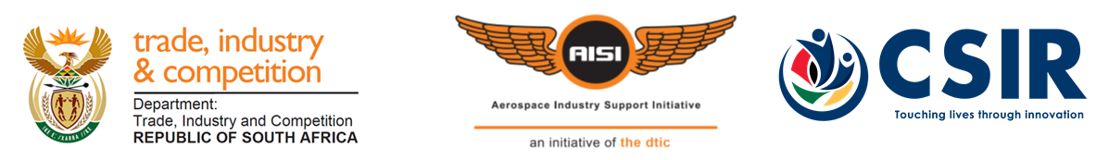
An Initiative of the dtic, hosted and managed by the CSIR

Table of Contents

Contents
Table of Contents i
1 Introduction 1
1.1 Organisational Profile 1
2 Qualifying and Differentiation Criteria 2
2.1 Aeronautics, space or defence related manufacturing SMME in the Advanced Manufacturing Environment 2
2.2 BBBEE status and % Black Owned 3
2.3 Design or manufacture of components for South African and International aerospace integrators/sub-systems suppliers and SMMEs. 4
3 SMME Interventions 5
4 Supporting Documentation 6
5 Signatory 7
5.1 Signature 7
6 Appendices 8

Introduction

Organisational Profile
Please provide a brief profile about your organisation (include BBBEE status).

Qualifying and Differentiation Criteria

Aeronautics, space or defence related manufacturing SMME in the Advanced Manufacturing Environment
Please discuss your company role in the national and international advanced manufacturing environment. Please state the number of years your organisation has been involved in the aerospace manufacturing environment.

BBBEE status and % Black Owned
Please provide details on your current BBBEE status and % Black Owned. Please provide all certificates to verify status and % black owned.

Design or manufacture of components for South African and International aerospace integrators/sub-systems suppliers and SMMEs.
Please provide details on your current track record in the aerospace or defence related industry with regards to the design or manufacture of aerospace components for national and international OEMs. Details must include the number of national and international contracts in place.

SMME Interventions

Please select the intervention/s which is/are required at the SMME (Mark with an X)

Technology Enhancement
  - Technology Validation
  - Technology Transfer
Standards and Accreditation
  - ISO 9001
  - ISO 14001
  - AS/EN 9100
  - Other (please specify)
Supply Chain Optimisation
  - Process Optimisation

Please provide details on the selection above. Why is it required at the SMME?

Supporting Documentation

Please provide any supporting documentation (valid tax clearance certificate)

Signatory

Signature
I hereby confirm that the information provided in the proposal is accurate, and understand that the AISI is under no obligation to approve the proposal, should the management committee of the AISI conclude that the project does not meet the AISI mandate.

SMME:

Signature
Name:
Position:
Date:
Telephone number:
Email:

Appendices

