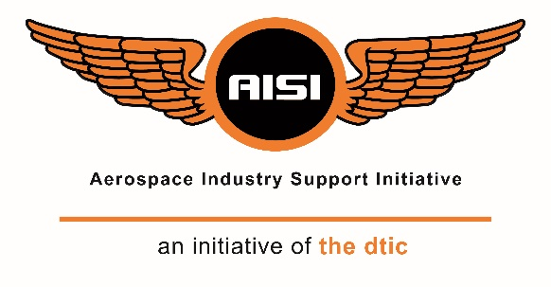

Identification of Beneficiaries of the Marine Manufacturing and Repairs Supplier Development Programme – Standards and Accreditations Intervention

EoI No: 001/21/04/2021
Response Template

Contact Details of Applicant

Organisation:

Address:

Contact Person:

Telephone No:

Fax No:

Email:

Organisation Name:
xxx

Please enter your organisation name in heading above and remove this text…

Compiled by:
Authors:
Date:

An Initiative of the dtic, hosted and managed by the CSIR

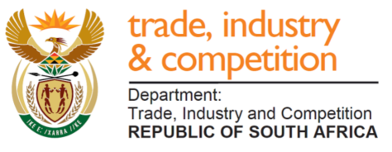

Table of Contents

Contents
Table of Contents i
1 Introduction 1
1.1 Organisational Profile 1
2 Qualifying Criteria 2
2.1 Qualification Evaluation Factors 2
2.2 Critical Evaluation Factors 2
2.3 Declaration of Additional Funding Received or Applied For 2
3 Standards and Accreditations Intervention 3
4 Differentiation Factors 5
4.1 Percentage black owned, percentage black women owned, percentage youth owned: 5
4.2 B-BBE compliance 5
4.3 SMME Status 5
4.4 Experience in Marine or Related Industry 6
4.5 Impact of intervention 6
5 Supporting Documentation 7
6 Signatory 8
6.1 Signature 8
7 Appendices 9

Introduction

Organisational Profile
Please provide a brief profile of your organisation (i.e. typical information found on a company website).
Enter your organisational profile here…

Qualifying Criteria

Qualification Evaluation Factors
Please confirm that your organisation meets the qualification evaluation factors by indicating compliance with the requirements in Table 1 below. Please provide supporting documents (e.g. sworn affidavits, (tax and other) certificates, etc.) to verify compliance in Section 5 of this document.
Table 1: Qualification evaluation factors
Qualification Evaluation Factors | Yes | No
South African registered company
Valid tax clearance certificate
B-BBEE compliant

Critical Evaluation Factors
Please confirm that your organisation meets the critical evaluation factor by indicating compliance with the requirement in Table 2. Please briefly discuss the role of your organisation in the marine manufacturing, associated services, and other related manufacturing industry. State if your organisation is currently active in the marine industry, or want to access it. Please discuss how the products that your organisation offers could support the marine industry. Reference to the targeted component list in the Terms of Reference (ToR) document should be considered (if applicable).

Table 2: Critical evaluation factors
Critical Evaluation Factors | Yes | No
Provision of components that support or could support the marine industry (see Section 2.2 of response template as a guide).

Briefly motivate the selection in Table 2 here…

Declaration of Additional Funding Received or Applied For
Please declare all additional funding applied for or received for this project. (Only projects which are not already receiving funding from other government programmes are eligible.)
Additional funding applied for or received if applicable…

Standards and Accreditations Intervention

Assistance provided to programme beneficiaries to obtain marine certifications (including but not limited to classification society certifications with one or more of the IACS affiliate bodies; other marine certifications such as SAMSA, SABS, CE, ISO, ABYC; or possibly other certifications such as ISO certification). Programme beneficiaries may also request assistance with other support relating to the certification process (e.g. engineering support) as depicted in Figure 1.

Figure 1. Standards and Accreditation Interventions

- Please indicate which intervention in Table 3.
- Please provide details on the selection (assistance is being sought for).
- What is the nature of the assistance required?
- Please also provide a list of certifications that your organisation already has.
Table 3: Standards and Accreditations enhancement intervention Add another column called “comment” after no
Standards and Accreditations Intervention | Yes | No | Comment
Classification society certification(s)
Other marine certification(s)
International Organisation for Standardisation (ISO)
Engineering support for certification(s)
Testing and related services for certification(s)

Details of the accreditations, certifications and/or support being sought, as well as certifications already held, here …

Differentiation Factors

Percentage black owned, percentage black women owned, percentage youth owned:
Please provide the percentage of your organisation which is black owned, black female owned as well as youth owned (include age bracket). Please provide supporting evidence in Section 5 of this document.

Qualification Evaluation Factors | %
Percentage black owned
Percentage black women owned
Percentage youth* owned
* South Africa's National Youth Policy, as well as its National Youth Commission Act and its Integrated Youth Development Strategy (draft 1, 2), defines youth as 14 to 35 years of age.

B-BBE compliance
Please provide the B-BBEE level of compliance for your organisation. Please provide supporting evidence in Section 5 of this document.
B-BBEE level : __.

SMME Status
If your organisation qualifies as an SMME, please complete Table 4 as accurately as possible. Please provide supporting evidence in Section 5 of this document where applicable. (Note A manufacturing SMME is defined in accordance with the Revised Schedule 1 of the National Definition of Small Enterprise in South Africa published on 15 March 2019 by the Department of Small Business Development. According to this schedule a manufacturing SMME is defined as having less than):
- 250 full time employees; and
- R170 million annual turnover

Table 4: SMME details
SMME Criterion
Number of full-time employees:
Annual turnover [in ZAR]:

Experience in Marine or Related Industry
Further to Section 2.2, please state the number of years your organisation has been involved in the marine industry. If your organisation has not been involved in the marine industry clearly indicate (sufficient evidence) how this support will aid you to become involved in the marine industry
Evidence to support this motivation (e.g. letters of reference, successfully complete projects, etc.) would be helpful.
Details of experience (number of years, examples of projects, etc.) in the marine or related industry…

Impact of intervention
Please provide a narrative motivating the requested intervention(s), as well as the impact that the intervention(s) would likely have on your organisation. The motivation should include information related to new (or additional) business opportunities which could result from the proposed intervention (e.g. local opportunities, export opportunities, localisation of imported technology, etc.). If possible, please provide letters of support from third parties in the marine value chain that have expressed an interest in the product that the intervention applies to. If it is not possible to provide letters of support, please provide a detailed motivation which is fact- and evidence-based, and quantitative rather than qualitative. (Please note that a letter of support does not necessarily have to commit the third party in the marine value chain to specific sales or orders, but should indicate their interest in the product in question.) Please provide supporting evidence in Section 5 of this document.
Details of impact here…

Supporting Documentation

Please provide any supporting documentation in this section.
- Evidence of Black Owned
- Evidence of Black Women Owned
- Evidence of Youth Owned
- Evidence of B-BBEE compliance
- Tax clearance certificate
- Letters of support (as per Section 4.4 and 4.5)
- Additional supporting documents

Signatory

Signature
I hereby confirm that the information provided in the proposal is accurate and understand that the AISI is under no obligation to approve the proposal, should the management committee of the AISI conclude that the project does not meet the AISI mandate.

Signature

Name:
Position:
Date:
Telephone number:
Email:

Appendices

Please provide any additional information here if applicable.

