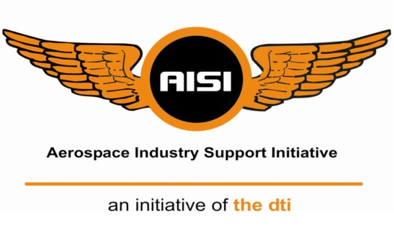

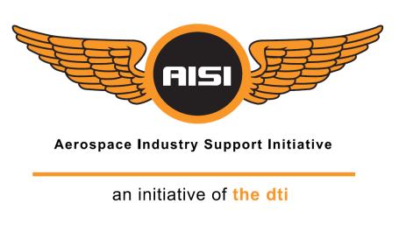**Industry Focused Development and Technology Support Programme:**

**An Initiative of the dti, hosted and managed by the CSIR**

**2018/19**

**Instructions**

* Submit the completed application as follows:
  + Deliver hard copies to CSIR Building 10, Meiring Naudé Road, Brummeria, Pretoria, 0184
* Direct any queries to the AISI Project Manager:
  + Livison Mashoko
  + Email: [lmashoko@csir.co.za](mailto:lmashoko@csir.co.za)
  + Tel no: (012) 841-4466

|  |  |
| --- | --- |
| Contact Details of Applicant | |
| Organisation: |  |
| Address: |  |
| Contact Person: |  |
| Telephone No: |  |
| Fax No: |  |
| Email: |  |

Project Title 1

*\*\** < *Project value ≤ R 750 000.00\*\**

**An Initiative of the dti, hosted and managed by the CSIR**

Date

Organisation:

Compiled by:

Authors:

Date:



# Executive Summary

*In half a page or less, summarize the main reasons for performing the project, the objectives, the extent of the design or research that your company/team aims to achieve. Highlight the technical proposal and management approach (e.g. include project period, final budget etc.)*

# Table of Contents

Contents

Executive Summary i

Table of Contents ii

1 Introduction 1

1.1 Organisational Profile 1

1.2 Background and Motivation 1

1.3 Market/Industry Opportunity 1

1.4 Literature Review 1

1.5 Project Goal 1

1.6 Project Objectives 1

1.7 Strategic Nature of Project 1

1.8 Applicable Thematic Area 1

1.9 Technology Readiness Level 2

2 Project Management 3

2.1 Description of Task Phases 3

2.2 Deliverables 3

2.3 Timeline 3

2.4 Budget (VAT Excluded) 3

2.5 Roles and Responsibilities 3

2.6 Reporting 3

2.7 Declaration of Additional Funding Received or Applied For 3

3 Impact and Benefits 4

3.1 Potential Industry and Organisational Benefit 4

3.2 Human Capital Development 4

3.3 Skills and Knowledge Transfer 4

3.4 Project Outcomes in Support of Achieving AISI Goals 4

3.5 Partners and Collaborators 4

4 Additional Information 5

5 Supporting Documentation 6

6 Signatory 7

6.1 Signature 7

7 References 8

8 Appendices 9

# Introduction

## Organisational Profile

*Please provide a brief profile about your organisation (include BBBEE status, attach certificate).*

### Type of application

*Please indicate whether you are applying as an OEM or SMME*

|  |  |  |
| --- | --- | --- |
|  | ***OEM*** | ***SMME*** |
| *Type of Application (Choose one in accordance with definitions in the ToR)* |  |  |

## Background and Motivation

*This section should demonstrate the company’s/team understanding of the technical problem/s. Provide a background and motivation for the project (what makes the project different?). What are the existing gaps and challenges in the market and how does your project address these challenges.*

## Market/Industry Opportunity

*Please provide details of the market/ Industry opportunity emanating from the project*

## Literature Review

*Please provide a description on how you identified the needs and requirements for your project as well as supporting literature that will assist in understanding the problem. Do not provide a list of relevant literature.*

## Project Goal

*The project goal is a statement that summarizes what the project is going to achieve. It can be general, technical and non-technical but must provide a direction for the project.*

## Project Objectives

*Define the scope of the work and clearly state the project objectives.*

## Strategic Nature of Project

*Discuss the strategic nature of the project; make reference to specific policies/documents that highlight the importance of undertaking this project.*

## Applicable Thematic Area

*Please indicate the relevant thematic area to which your project falls under. You are allowed to pick more than one thematic area where applicable. Indicate with an* ***X*** *where applicable.*

|  |  |
| --- | --- |
| **Thematic Area** | **Applicable?** |
| Avionics |  |
| Radar Technology |  |
| Advanced Materials |  |
| Advanced Manufacturing and processing (including certification of manufacturing processes) |  |

## Technology Readiness Level

*Please specify the current TRL value of the technology being proposed (TRL value definitions are provided in the request for proposals documentation)*

# Project Management

## Description of Task Phases

*Please provide a brief description of the tasks/phases required to successfully complete this project.*

## Deliverables

*Specify all deliverables/outcomes expected upon completion of the project.*

## Timeline

*Please provide a timeline with milestones i.e. Gantt chart*

## Budget (VAT Excluded)

*Please provide a complete breakdown of the budget. How will the grant be utilized (manpower, equipment, running costs etc.)? What contribution will be made by the applicant? Complete the table below. Link tasks/phases mentioned above to budget items. The Budget must be separate from the Proposal – PART 2: Pricing Proposal, B-BBEE and other Mandatory Documentation as indicated in the Call for Proposals (page 15).*

|  |  |  |  |
| --- | --- | --- | --- |
| *Description* | *AISI Contribution* | *Applicant Contribution* | *Total* |
|  |  |  |  |
|  |  |  |  |

## Roles and Responsibilities

*Division of responsibilities amongst team members. An organogram will be beneficial. Main point of contact for projects, contracts etc.*

## Reporting

Report guidelines will be provided by the AISI. The reports will include a workplan, submitted one month after commencement of project and a minimum or two interim progress reports as well as a final report upon completion of project.

## Declaration of Additional Funding Received or Applied For

*Please declare all additional funding applied or received for this project*

# Impact and Benefits

## Potential Industry and Organisational Benefit

*What are the major benefits of this project to the aerospace industry and your organisation?*

## Human Capital Development

*Will there be job creation or job retention if this project is supported? Will there be any personnel to be trained as part of the project?*

## Skills and Knowledge Transfer

*Will any skills and/or knowledge be transferred to industry at the completion of the project? Is there a willingness to host workshops and training sessions to inform industry about the technology developed?*

## Project Outcomes in Support of Achieving AISI Goals

*Explain how the outcome of this project will assist the AISI in achieving its goals?*

## Partners and Collaborators

*Please list all prospective partners and collaborators (e.g. SMMEs, tertiary institutes). What capacity will they be involved in and what is their level of involvement? Note: A letter confirming collaboration between all parties is required (attach to this proposal)*

# Additional Information

*List here any other information or comments which may be important in consideration of this project*

# Supporting Documentation

*Please provide any supporting documentation that will assist with the project proposal (include BBBEE and tax certificates)*

*The B-BBEE and other Mandatory Documentation must be separate from the Proposal – PART 2: Pricing Proposal, B-BBEE and other Mandatory Documentation as indicated in the Call for Proposals (page 15).*

# Signatory

## Signature

I hereby confirm that the information provided in the proposal is accurate, and understand that the AISI is under no obligation to approve the proposal, should the management committee of the AISI conclude that the project does not meet the AISI mandate.

|  |  |
| --- | --- |
| Signature |  |
| Name: |  |
| Position: |  |
| Date: |  |
| Telephone number: |  |
| Email: |  |

# References

# Appendices