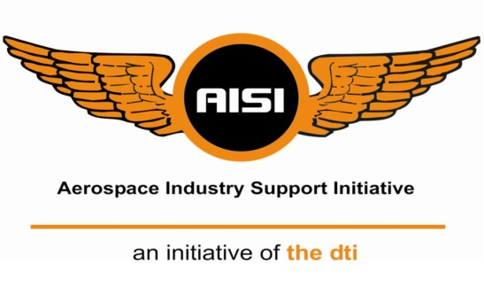

**Identifying Advanced Manufacturing Aerospace OEMs and SMMEs to participate in the AISI Technology Based Supplier Development Programme**

*EoI No: 001/05/03/2018*

OEM Template

|  |  |
| --- | --- |
| Contact Details of Applicant | |
| Organisation: |  |
| Address: |  |
| Contact Person: |  |
| Telephone No: |  |
| Fax No: |  |
| Email: |  |

*OEM Name*

**An Initiative of the dti, hosted and managed by the CSIR**

Date

Compiled by:

Authors:

Date:

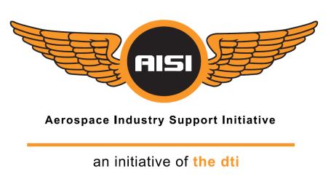

# Table of Contents

Contents

Table of Contents i

1 Introduction 1

1.1 Organisational Profile 1

2 Qualifying Criteria 2

2.1 Aerospace manufacturer operating in the Advanced Manufacturing Environment 2

2.2 BBBEE status and % Black Owned 3

2.3 Supplying of aerospace components for South Africa and International OEMs 4

2.4 Manufacturing of aerospace components for South Africa and International OEMs 5

2.5 Provision of engineering services that support the aerospace manufacturing industry 6

2.6 Assistance to current SMME supplier base 7

3 OEM Interventions 8

4 Supporting Documentation 9

5 Signatory 10

5.1 Signature 10

6 Appendices 11

# Introduction

## Organisational Profile

*Please provide a brief profile about your organisation (include BBBEE status).*

# Qualifying Criteria

## Aerospace manufacturer operating in the Advanced Manufacturing Environment

*Please discuss your company role in the national and international advanced manufacturing environment. Please state the number of years your organisation has been involved in the aerospace manufacturing environment.*

## BBBEE status and % Black Owned

*Please provide details on your current BBBEE status and % Black Owned. Please provide all certificates to verify status and % black owned.*

## Supplying of aerospace components for South Africa and International OEMs

*Please provide details on your current track record in the aerospace industry with regards to the supply of aerospace components to national and international OEMs. Details must include the number of national and international contracts in place.*

## Manufacturing of aerospace components for South Africa and International OEMs

*Please provide details on your current track record in the aerospace industry with regards to the manufacture of aerospace components for national and international OEMs. Details must include the number of national and international contracts in place.*

## Provision of engineering services that support the aerospace manufacturing industry

*Please discuss the current engineering services available at your company that support the aerospace manufacturing industry. Please list and describe all services.*

## Assistance to current SMME supplier base

*Please provide details on your current SMME supplier base involved with the manufacturing of aerospace components. List the SMMEs you have supported and the level of support (financial, man hours etc)*

# OEM Interventions

*Is support required for any technology ehnancement projects? If so, please elaborate.*

# Supporting Documentation

*Please provide any supporting documentation (valid tax clearance certificate)*

# Signatory

## Signature

I hereby confirm that the information provided in the proposal is accurate, and understand that the AISI is under no obligation to approve the proposal, should the management committee of the AISI conclude that the project does not meet the AISI mandate.

|  |  |
| --- | --- |
| Signature |  |
| Name: |  |
| Position: |  |
| Date: |  |
| Telephone number: |  |
| Email: |  |

# Appendices